Supporting Tallaght University Hospital’s (TUH) Integrated Care for Older Persons: Testing an approach to identify the common housing hazards in housing affecting older people in South Dublin

Context:
The quality of older people’s housing is a determinant of health. This study will explore the linkages between housing conditions and older people’s health with a view to informing housing providers and policy makers of the key components of healthy homes. This proposal will involve stakeholder engagement, research and housing case studies in the Tallaght area to investigate the links between housing conditions and the health of older people, and the impact on TUH healthcare delivery. The overall findings will be used to support the TUH integrated care team by highlighting key housing related issues to improve the health of older people in their homes. This project will also be used to initiate a larger conversation and promote further research into housing conditions and TUH’s Integrated Care for Older Persons.

Why is this study being conducted?
Housing is critical to the health and well-being of older people and is a vital part of preventative medicine in the community. Supporting community health is central to Tallaght University Hospital’s (TUH) Integrated Care for Older Person’s Team who provide multi-disciplinary care to improve the quality and outcomes of care for older persons and their carers and support persons to live well in their own homes and communities.

The TUH team is part of the Integrated Care Programme for Older People (ICPOP) aimed at promoting the development of services and care pathways to improve outcomes for older people in the community. These pathways involve various aspects of the built environment including housing, which acts as critical infrastructure for the hospital and community care ecosystem. In this regard it is important to understand the impact of housing on the health of older people in the Tallaght area and the downstream consequences for TUH in terms of both preventative medicine and the direct care of older people as patients.

The Research Team: The Principal Investigator (Professor Des O’Neill) and one of the co-investigators (Professor Sean Kennelly) will oversee the study from a health perspective and in relation to their role in the Integrated Care Team. However, the literature review; qualitative data collection and analysis will be carried out by research staff from TrinityHaus, and the technical assessments will be contracted to the Building Research Establishment [BRE Ireland] who have expertise in this field in Northern Ireland and UK contexts. The involvement of a health care professional in this research process is essential in terms of identifying hospital patients who can participate in the case studies to be undertaken and advising on areas of enquiry in the research questions.

Background
A consortium was established in 2019, chaired by The Housing Agency, to research the common housing hazards in Irish housing affecting older people, with the aim of helping them to live more healthily and safely in their homes. A scoping study commissioned by the BRE Trust undertook a review of international research on the impact of housing on health, particularly the health of older people.(The Cost of Poor Housing in Ireland) The research concluded that around 160,000 (8%) of Irish homes are likely to present a serious health and safety risk to their occupants (and visitors), as measured through the Health and Safety Rating System [HHSRS], with the most common severe home hazards relating to cold homes and falls.

Partners
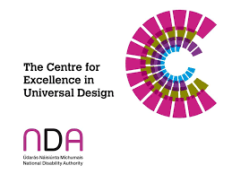 | The Centre for Excellence in Universal Design (CEUD) is dedicated to enabling the design of environments that can be accessed, understood and used regardless of a person's age, size, ability or disability. The CEUD is part of the National Disability Authority.
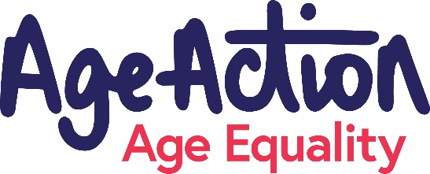 | Age Action advocates for a society that enables all older people to participate and to live full, independent lives, based on the realisation of their rights and equality,  recognising the diversity of their experience and situation. Our work is driven by an organisation that lives out its values of dignity, participation, diversity, social justice, and professionalism.
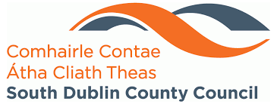 | South Dublin County Council is the authority responsible for local government in the county of South Dublin, Ireland. The council is responsible for housing and community, roads and transportation, urban planning and development, amenity and culture, and environment and operates in the catchment area of Tallaght University Hospital.
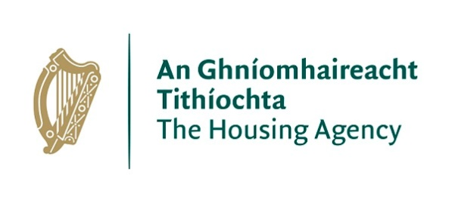 | The Housing Agency is a government agency focused on supporting local authorities, the Department of Housing, Local Government and Heritage and Approved Housing Bodies (AHBs). We actively support the delivery and management of social and affordable housing by local authorities and AHBs and we work closely with the Department in the development and implementation of housing policy.
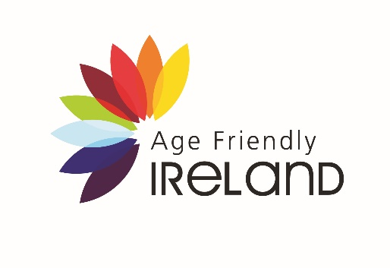 | Age Friendly Ireland operates as a shared service of local government, hosted by Meath County Council. The national Age Friendly Programme supports cities, counties and towns across Ireland to prepare for the rapid ageing of our population by paying increased attention to the environmental, economic and social factors that influence the health and well-being of older adults.
 | Building Research Establishment delivers innovative and rigorous products, services, standards and qualifications which are used around the globe to make buildings better for people and for the environment.

Research aims: The research aims to investigate the link between common housing conditions and hazards that affect older people’s health in the South Dublin area, and their impact on TUH healthcare delivery.

Process: This will involve stakeholder engagement, research and housing case studies in the Tallaght area to investigate the links between housing conditions and the health of older people, and the impact on TUH healthcare delivery. The overall findings will be used to support the TUH integrated care team by highlighting key housing related issues to improve the health of older people in their homes. This project will also be used to initiate a larger conversation and promote further research into housing conditions and TUH’s Integrated Care for Older Person’s. As set out in the ICPOP, engaging with key stakeholders, particularly older people in the community, is essential. This project will engage with key stakeholders to understand key health related housing conditions and work with these stakeholders to achieve the research objectives. This engagement will primarily involve interviews and focus groups.

Objectives: these outcomes will be achieved through the following objectives:
- Identify common conditions and hazards in local housing that affect older people and impact on their health.
- Outline the impact of these housing conditions on TUH healthcare delivery and in particular the work of the integrated care team. This may include poor general health outcomes in hospital catchment area, hospitalisation due to poor housing or hazards, or patient discharge issues due to housing that is unsuitable for recovery or rehabilitation.
- Work with the TUH integrated care team, SDCC, and AFI to deter how these findings can be used to enhance care pathways and inform decision making around housing adaptations.
- Work with TUH, SDCC to identify specific housing improvements/adaptations that a) help maintain/improve general health, b) targeted housing related measures that support specific aspects of integrated care, and c) provide supportive conditions on discharge from hospital
- Initiate a wider conversation about the relationship between housing conditions and the health of older people, the role of housing in the integrated care of older people, and the relationship between TUH and local housing in terms of preventative medicine and healthcare delivery.
- Use this project to investigate and identify opportunities for further investigation of housing conditions for older people and the interaction with TUH integrated care in the wider SDCC area. This will include the identification of appropriate technical assessment methodologies and processes to be used in any further project.

Contact details:
Thomas Grey  TrinityHaus, Trinity College Dublin, Dublin 2  Tel: (01) 896 3802  Email greyt@tcd.ie | Prof Desmond O’Neill  Centre for Ageing, Neuroscience and the Humanities, Tallaght University Hospital  Tel: 086 826 0414  Email: Desmond.ONeill@tuh.ie

Research study funded by:

