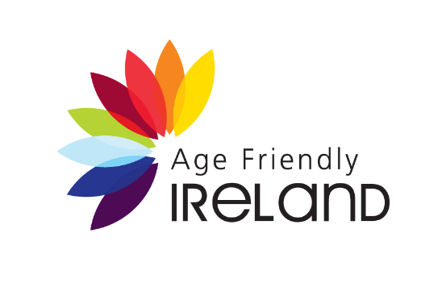

Press Release

Embargo: 28th November 2023 at 2pm

Age Friendly Homes to meet Ireland’s rapidly growing Ageing Population Need

Local authorities are building Age Friendly Housing around the country in line with national policy to prepare for an ageing population.
On 28th November Kieran O’Donnell, TD, Minister of State for Local Government and Planning at the Department of Housing, Local Government and Heritage launched a case study publication featuring Age Friendly Housing Models from local authorities across Ireland.
Age Friendly Ireland developed this report in collaboration with Age Friendly Technical Advisors in each of the 31 local authorities. The document highlights how Ireland is preparing housing provision for the ageing population.
As well as population growth, Census 2022 data confirmed that Ireland’s ageing population is increasing significantly due to welcome increasing life expectancy. This is a very welcome development, along with a positive trend in healthy life years. In fact in Ireland the population aged 65 and over has increased by 35% since 2013, considerably higher than the EU average increase of 17.3%
The 2022 Census of Population indicates there are over 781,000 people aged 65 and over living in Ireland, currently about 15% of the population. It is expected that by 2030, 20% of the population will be aged 65 and over. The number in this bracket is projected to increase to 1.6 million by 2051.
Chief Executive of Meath County Council, host of the Age Friendly Ireland Shared Service, Fiona Lawless explains:
“The development of Age Friendly Housing is critical to ensuring that people have a good quality of life in later years. Although older people in Ireland have high rates of self-reported good health, compared to European neighbours, nonetheless the experience of ageing often brings changes to mobility, dexterity and other abilities that impact on a person’s interaction with built environments. By designing and building Age Friendly Homes within our capital programmes, local authorities are ensuring that older communities have suitable living conditions that support their independence, health and wellbeing in advancing years.”
The Programme for Government | Our Shared Future (2020) has a stated ambition to support older people to live as independently as possible within their own homes and communities with an overarching vision of an Age Friendly Ireland. Pathway 2 of the national policy Housing for All commits to identifying suitable housing options for older people, including with reference to location, opportunities for rightsizing and supporting older people to participate in their communities.
This report takes a case study approach in presenting a portfolio of Age Friendly Housing developments and key learnings from their development. Each case study provides a description of the housing development, the funding source and technical specifications.
An ‘Age Friendly Home’ has Universal Design features making it easy to approach and enter and easy to move around in. They have level access at front and rear, and specific features such as level access showers or wet rooms, and low maintenance landscaping. They are energy efficient and located in close proximity to shops, services and public transport routes. Age Friendly Homes are integrated into the community as part of multi-generational residential spaces.
One case study featured is Cúinne an Bhroic, a Clare County Council social housing scheme, comprising 25 units within an existing neighbourhood and established community in Tulla town. The 25 units include 8 x 2 bedroom apartments, four of which are ground floor single storey. Three of the 3-bedroom houses are bungalows for families with extenuating medical conditions requiring wheelchair accessible accommodation planned and adapted in collaboration with a HSE Occupational Therapist. One of the 4-bedroom houses is ground floor single story, specially adapted and fully accessible. The development also includes Age Friendly and Accessible car parking spaces dispersed on site. In close proximity to Tulla town, the homes are within 400 metres of shops, services and amenities including a post office, credit union (approximately a 5 minute walk) and within 800 metres to the bus stop, medical centre, pharmacy, church, library, bank, and local grocery shops.
19
Minister of State for Local Government and Planning, Kieran O’Donnell, TD, highlighted: “The ambition of national housing policy is to recognise the diverse needs of people across their lifetime. Needs change as people age, so for older people, the emphasis is on greater accessibility, warmer homes, enhanced safety and security, and low maintenance environments. Through their Housing Delivery Action Plans, local authorities are setting out specific targets to deliver housing for older people. Enhanced resources are available through my Department under the Housing for All policy to deliver social housing for older people. I congratulate local authorities, Approved Housing Bodies, private developers for working together to prepare a suitable supply of housing for older people, contributing to the Government’s vision of an Age Friendly Ireland. I am delighted to launch this publication which will be a significant resource that can facilitate the delivery of more age friendly housing across Ireland”

The top ten features of an Age Friendly Home are:

- Well-connected to local amenities (Town/Village/City Centre)
- Easy to approach and enter
- Connected to the outdoors
- Easy to move about in
- Accessible and adaptable toilets and bathrooms
- A second bedroom
- Easy to use fittings and fixtures
- Energy and cost efficient
- Good security systems
- Infrastructure for technology and assistive technology

- Ends –

Photos:

L-R: Minister Kieran O’Donnell; Catherine McGuigan, Chief Officer, Age Friendly Ireland Shared Service; Barry Lynch, Director of Services, Meath County Council
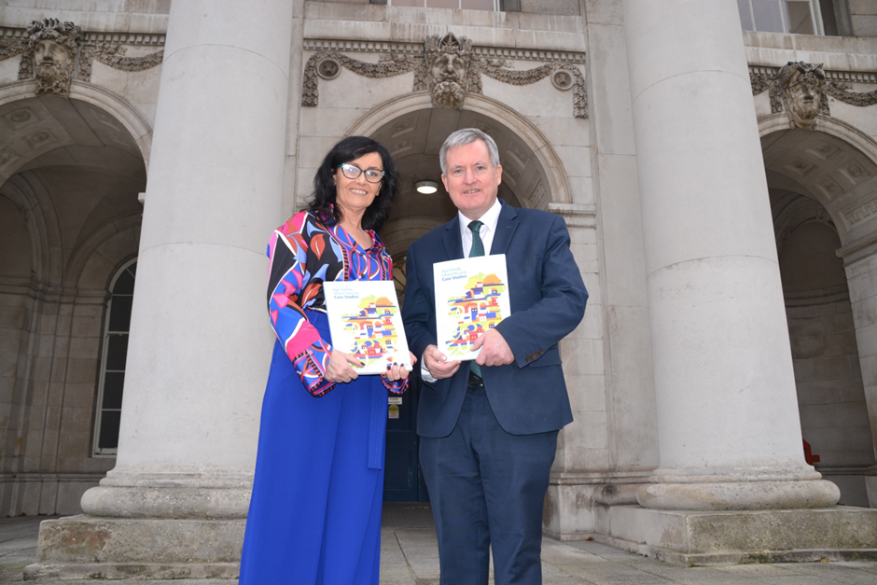
Minister O’Donnell pictured with Catherine McGuigan on the steps of Custom House, Dublin
Minister Kieran O’Donnell with a copy of the Age Friendly Housing Case Studies publication

