Technical Programmes - Age Friendly Ireland Housing Case Study

St. Joseph’s, Manor Hill, Waterford was recently nominated for the Age Friendly Housing Award for 2023. St Joseph’s, which was a former religious convent, is a state-of-the-art age friendly housing development that delivered 71 homes for residents aged 55 and over in a modern, spacious and distinctive setting, right in the heart of Waterford City.
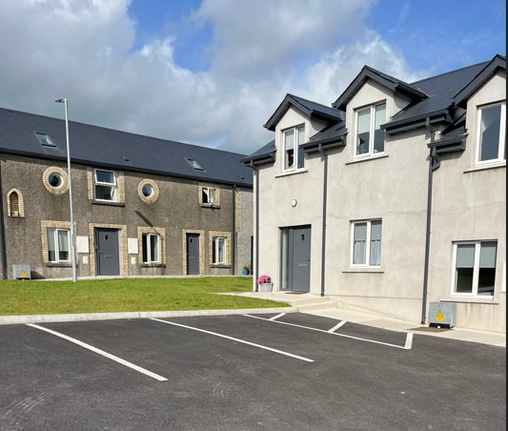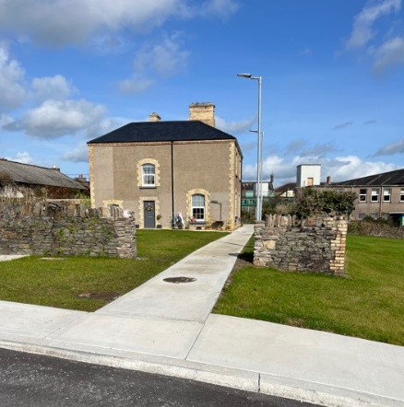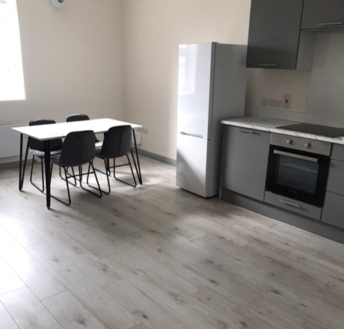
This development is an exemplar project for both city centre living for accommodation for older persons along with an opportunity to roll out a pilot scheme for a Rightsizing Policy for local authority tenants. Well done to Waterford City & County Council on the delivery of this wonderful Age Friendly development. 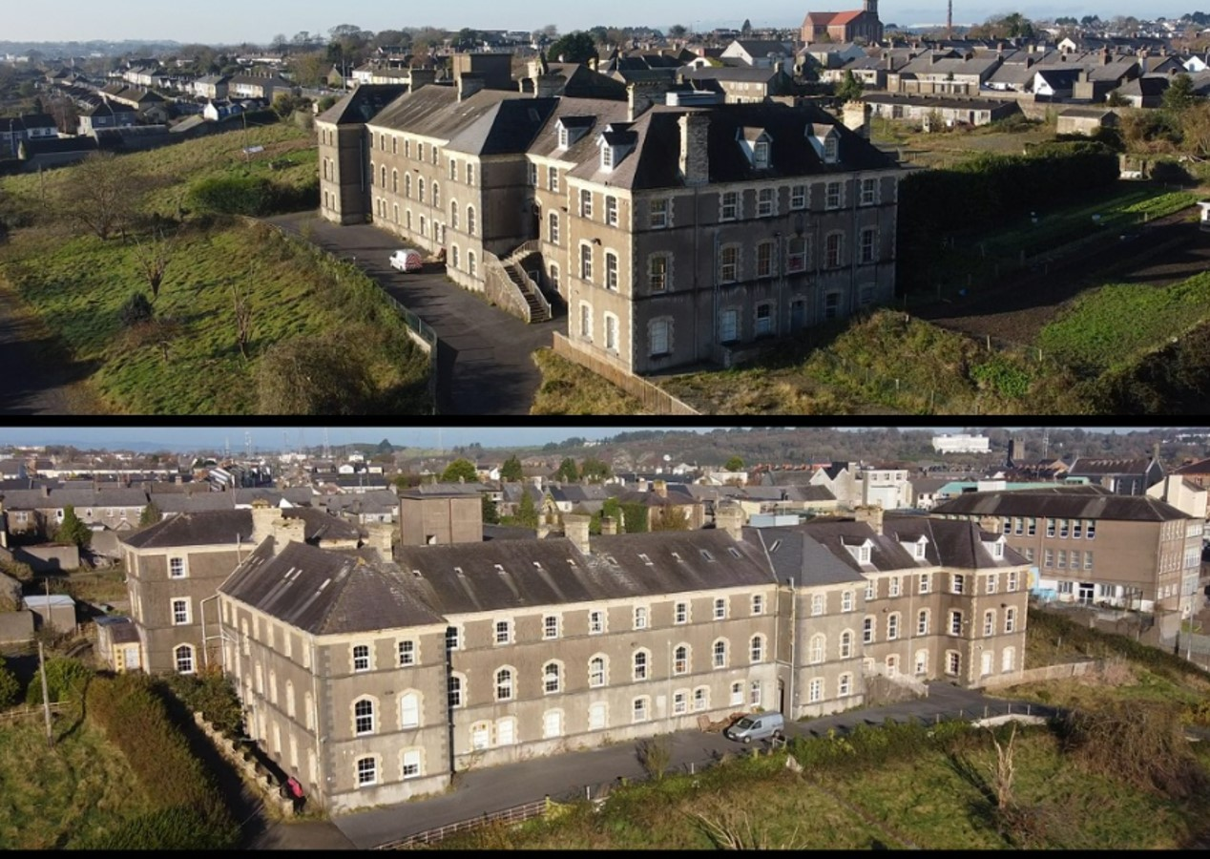

Further details of this development can be obtained at: https://agefriendlyhomes.ie/wp-content/uploads/2023/12/Age-Friendly-Housing-Case-Studies_November-2023.pdf

